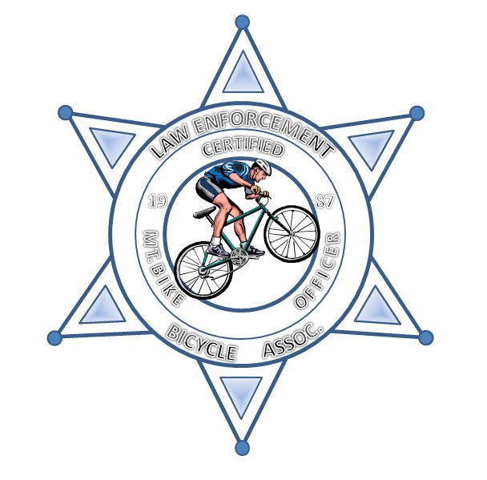
Law Enforcement Bicycle Association

Please accept this as my application for membership and/or request for training with the Law Enforcement Bicycle Association (L.E.B.A.). I acknowledge that cycling, mountain biking, as well as the police tactics, including firearms training are inherently dangerous activities. I agree to participate at my own risk and that the Law Enforcement Bicycle Association is an association formed to advance the training of police, security, military and emergency medical personnel. The efforts of which directly benefit me. In consideration of the agreement of the Law Enforcement Bicycle Association (L.E.B.A.) to accept me into its training program, hereby on behalf of heirs assigns, personal representatives, and myself. I release and forever discharge the Law Enforcement Bicycle Association, its employees, agents, members, sponsors, promoters, host departments and affiliates from all liability, claim, loss, cost or expense. And waive and promise not to sue on any such claims against any such person or organization, arising directly or indirectly from or attributable in any legal way to any negligence, action or omission. To act of any such person or organization in connection with sponsorship, organization or execution of any police, security, military or emergency medical service mountain bike training or sporting event. Including travel to and from such event, in which I may participate as a rider and/or student, member or spectator currently have no physical or mental condition that would impair my capability for full participation as intended or expected of me (except for):

For valuable consideration, I hereby grant to the Law enforcement Bicycle Association, its assigns, licenses and legal representatives the irrevocable right to copyright, publish and use in any form or media, for advertising, trade, stock use, or other lawful purpose any likeness or photographs in which I am included. I waive the right to inspect or approve the finished product, including written copy. I hereby release and agree to hold harmless L.E.B.A., its assigns and those operating under its authority from any liability by virtue of the lawful use of these pictures. I warrant that I am of legal age, and that I have read and understand the contents of this release.

I also acknowledge that my participation or payment for participation does not guarantee that I will complete or graduate from the training I am about to receive and that I may not be entitled to a refund. I further understand that upon graduation of any “basic” or “advanced” training that I am not certified to teach the skills I have just been taught. Doing so while using any or all of the information or material used or supplied or explained by the agent or instructor(s) of the Law Enforcement Bicycle Association may violate copyright and trademark laws of the United States Code, USC. And, can result in at least the removal of myself from the organization, revocation of any certificates and loss of fees paid for such training.

SIGNATURE: |  |  |  |  | DATE:
PRINT FULL NAME: |  |  |  | INSTRUCTOR INITIALS:

LEBA USE ONLY

INSTRUCTORS: |  |  |  | DATE:
COURSE NUMBER:

